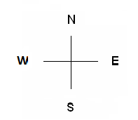
Baldridge Performance Angus 2022 Bull Sale Penning Map
West Barn- Yearlings
22 105 368
23 145 420
73 159
77 196
83 240
85 261
91 324
103 364

19 104 423
21 160
48 189
67 191
78 200
84 207
86 242
93 412
28 155 336
30 161 338
68 199 362
129 260 373
132 294 397
142 322 408
143 323 414

18 152
25 158
46 247
66 383
100 385
138 399
148 400
151
32 60 245
34 137
54 139
59 244
101 210 295
109 216 334
190 246
206 267

20 134 197 392
29 135 201 393
74 156 337 409
127 186 361 413
130 193 363 424
133 194 372
26 50 238
27 79 404
33 102
47 198
51 81 214
52 87 422
53 98
80 205

24 144 370
45 146 394
55 147
56 192
70 202
72 248
90 335
92 369
31 217 419
49 241
57 249
58 251
69 275
71 371
154 402
187 410

99 195 401
108 208 421
128 209
141 215
149 237
150 239
153 243
157 396

Sale Barn & East Barn
Lunch Room & Restrooms

