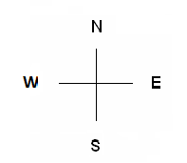
Baldridge Performance Angus 2022 Bull Sale Penning Map
East Barn- Coming 2’s
38 230
61 231
218 301
113 213 278
163 219
166 269
12 182 308
63 203
164 204
40 252 286
114 270 388
221 279

258
378
380
8 107 310
95 183
106 309
4 118 331
13 177 387
89 299
17 228 254
88 232 263
119 235
173 276 297
229 285 317
256 287
2

1

168
341
357
16 325
255 333
314 352
318 354
169 305
222 311
226 343
234 375
15 282
224 288
257 290
266 360
3 265
115 296
125 313
253 321
97 176
117 236
126 328
170 406

172 418
220
225
291
344
366
367
395
39 298
43 307
65 330
121 356
124 365
165 417
180
184
10 312
42 319
120 348
123 350
223 351
273 355
302
306
64 347
122 374
272 381
292 382
300 390
304 405
320
342
5 227
6 233
7 271
94 274
178 289
181 293
185 303
212 326
14 329 416
62 340
162 346
167 353
171 358
179 377
211 389
280 415
11 315
36 327
37 332
41 339
259 345
264 349
281 386
284 407

Sale Barn & West Barn

